**The Report Of Women Clothes Analysis**

Begüm Doğru

15.10.2021

**The Report Of Women Clothes Analysis**

This report presents the findings of the quantitative component of women product reviews that consists of a series structured review texts, various age groups, clothing categories of the brand.

**Inspiration**

Women are often associated with a shopping addiction. Therefore, the products in the women’s section are sold out much faster than the products in the men’s section. In this case, the brand will record the customer-sales inputs in order to establish a supply-demand balance and increase its profits, and will draw a path by analyzing these data.

***Data Visualization***

* What is the age group distribution of customers?

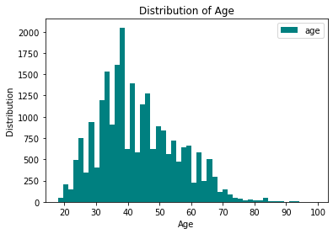

As can be seen in the graphic above, the age group of the customers who buy the most products of this brand is around 40. This is a harbinger that the brand can increase its earnings if it continues to launch its products addressed to this age group. We see that the sales rate decreases in customers after the age of 0-20 and 70+. As a result, we can determine the target audience of this brand as young and middle-aged women.

* What kind of clothes are the most sold?

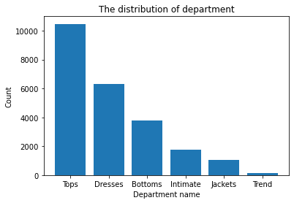

In this chart, we see that the tops are sold at a high rate. According to this distrubition, since the products in the best-selling category are sold out quickly, variety and serial stock service can be provided.

* Do customers recommend this brand?

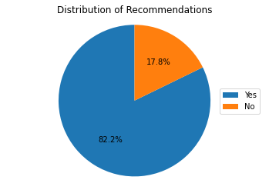

According to the result obtained from the feedback after receiving the product, it is seen that the satisfied ones are more than the dissatisfied ones.

* What is the sales distribution of clothes?

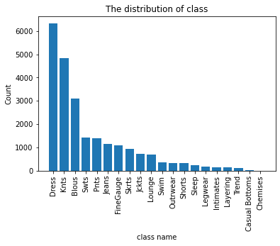

When we examine the table here, we see that the clothing categories are getting deeper. Tops departmend is divided into ‘Knits’, ‘Blouses’, ‘Sweaters’ and so we are viewing the most sold ‘Knits’ in this department.

* How do customers’ comments about the brand?

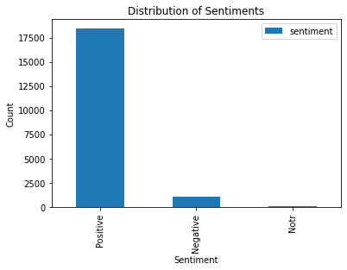

**Conclusion**

To briefly summarize the results of the graphs, the most shopping age group of this brand is the age group of 30-40. Customers mostly preferred to purchase Knits under the Tops department and the brand achieved a satisfaction rate of 82.2%.